**1. States = rownames(US Arrests)**

**Get states names with ‘w’.**

**Get states names with ‘W’.**

**Ans:**

The USArrests dataframe is as follows:

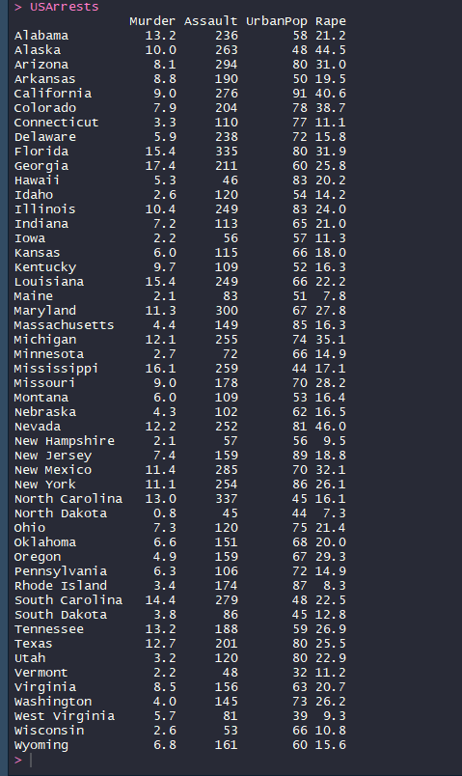

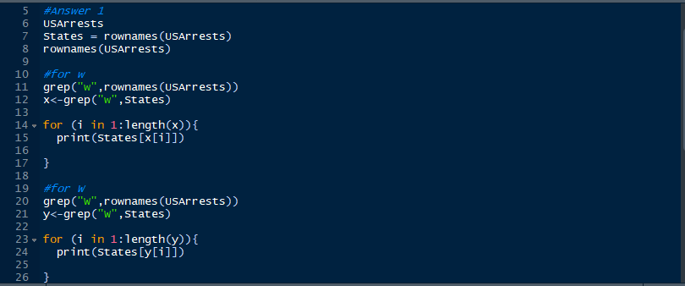

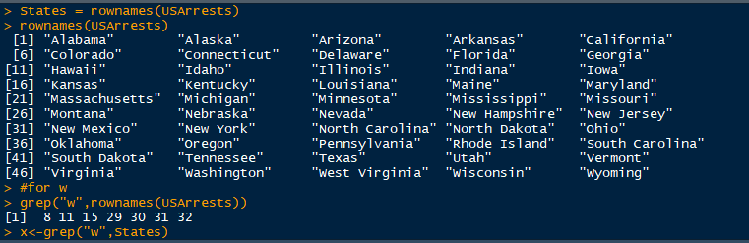

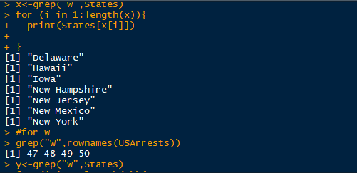

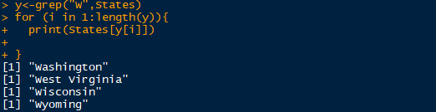

**2. Prepare a Histogram of the number of characters in each US state.**

